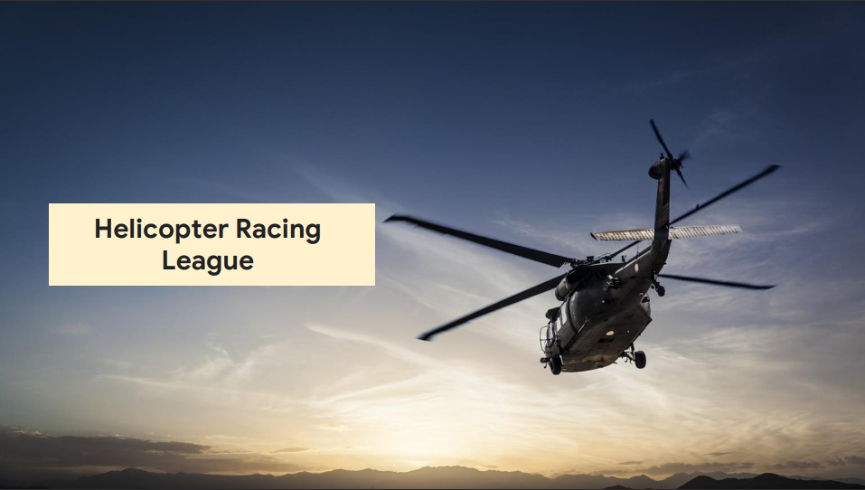

**Business Evaluation**

|  |  |  |
| --- | --- | --- |
| **Competitive racing league** | **Values** | **Immediate Goals** |
| Helicopter Racing League (HRL) is a global sports league for competitive helicopter racing. HRL holds the world championship and several regional league competitions where teams compete to earn a spot in the world championship. | ● High-adrenaline coverage to fans all over the world  ● Enhanced video streaming with integrated real-time race predictions  ● Season long interest and results for the sport | ● Migrate existing service to a new platform.  ● Expand use of AI and ML services to facilitate race predictions.  ● Serve content closer to users (lower latency) |

**Key business assumptions**

|  |  |  |
| --- | --- | --- |
| **Customers want real-time racing predictions and higherquality broadcasts** | **Business focus should be on predictive analytics, expanded serving capacity, and increased fan engagement** | **Potentially different storage solutions for racing videos and predictive analytics** |

**Technical Evaluation**

|  |  |  |
| --- | --- | --- |
| **Existing Environment** | **Technical Watch points** | **Proposed Solution** |
| Core of their mission-critical applications runs on their current public cloud provider. Video recording and editing is performed at the race tracks, and the content is encoded and transcoded, where needed, in the cloud. | Compute  ● Video encoding and transcoding is performed on VMs created for each job. | Compute Engine (transcoding) |
| Content is stored in an object storage service on their existing public cloud provider. | Storage  ● Large file object storage (BLOB) | Cloud Storage for fast streaming to delivery points |
| ● Video encoding performed on VMs  ● Race predictions use TensorFlow on VMs | Data (videos)  ● Large number of concurrent streaming video viewers  ● Ability to create “data mart” | ● Cloud CDN for low latency delivery  ● Cloud Data Fusion (cloudnative data integration and ingestion service |